**Task No. 1:** Create a database of a company which will hold employee info(_id,name,designation,salary,department) and department info(_id,name), insert 5 records on each table.

**Solution:**

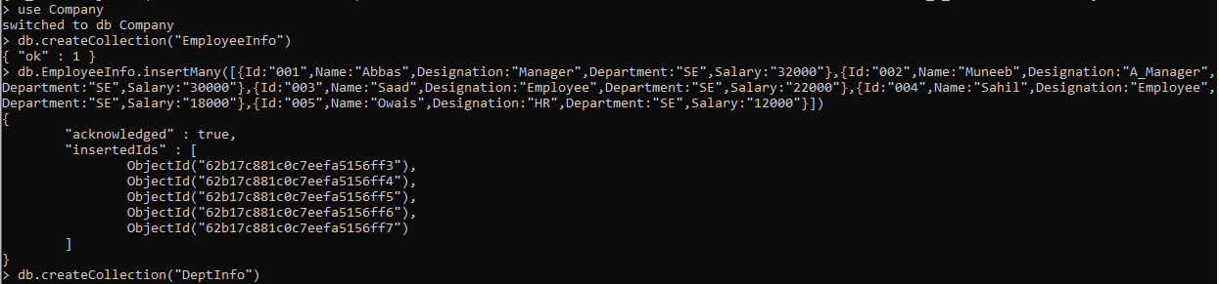

**Task No. 2:** Increase employee salary to 10% if salary =10000

**Solution:**

**Task No. 3:** View all records updated.

**Solution:**

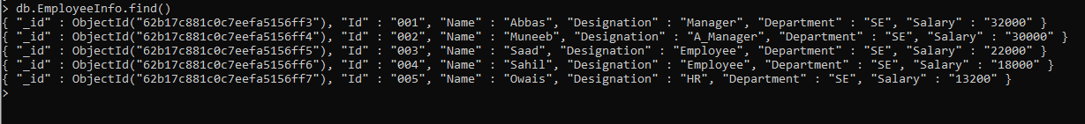

**Task No. 4:** Delete records from department where department id is 5.

**Solution:**

